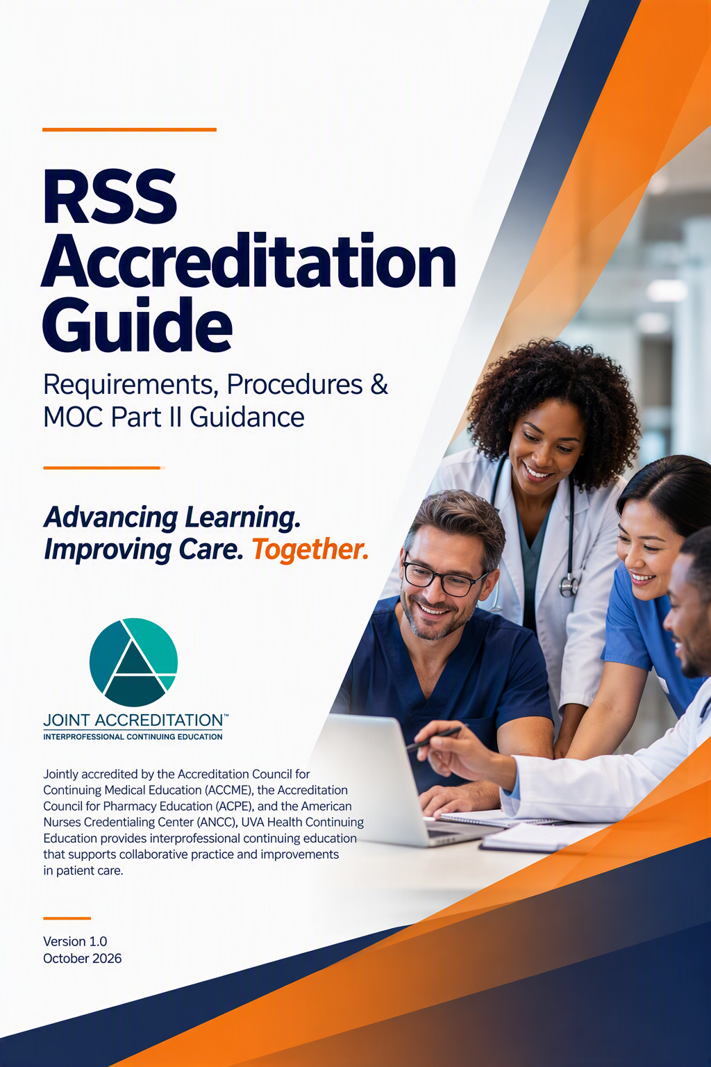


Table of Contents
RSS Quick Start Guide 2
SECTION I. RSS CE Requirements 4
SECTION II. MOC Part II Requirements 10
SECTION III. RSS Offering MOC Part II Procedures 13

Appendices
A. Sample Faculty Communications 16
B. Sample Learner Communications 18
C. Compliance Checklists 20
D. Standardized Evaluation Form
with Reflective Statement for MOC Part II 22
E. Additional Resources 23

RSS Quick Start Guide: Page 1 of 2
Key Steps for a Successful Regularly Scheduled Series
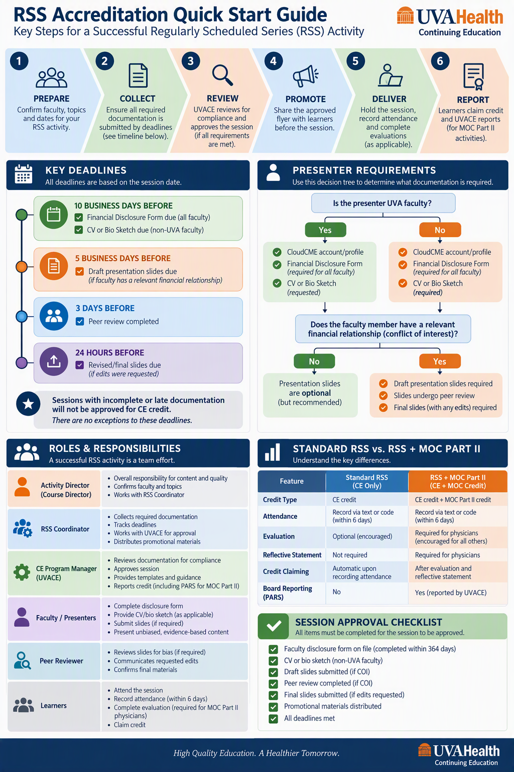

RSS Quick Start Guide: Page 2 of 2
Key Steps for a Successful Regularly Scheduled Series

SECTION I. RSS CE Requirements

Purpose
This policy establishes requirements for all Regularly Scheduled Series (RSS) activities seeking continuing education (CE) credit through UVA Continuing Education (UVACE).
The purpose of this policy is to ensure compliance with accreditation standards, maintain educational integrity, and support timely approval and reporting of CE activities. The objective is to ensure high quality, valid education content that is not influenced by financial conflicts of interest.

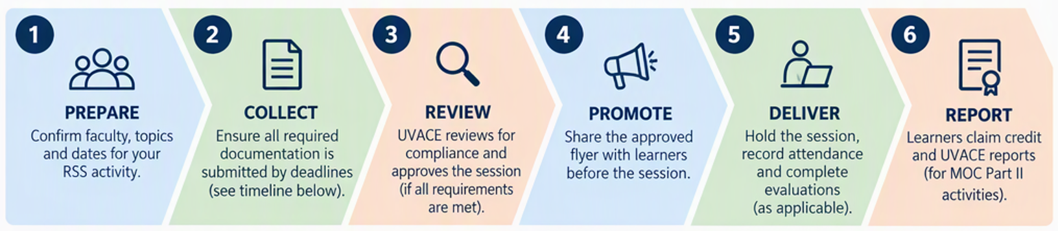
Scope
Section I applies to all RSS activities accredited through UVACE, including but not limited to Grand Rounds, Morbidity and Mortality Conferences (M&M), Tumor Boards, Journal Clubs, Case-Based Conferences, and other recurring educational activities.

Roles and Responsibilities
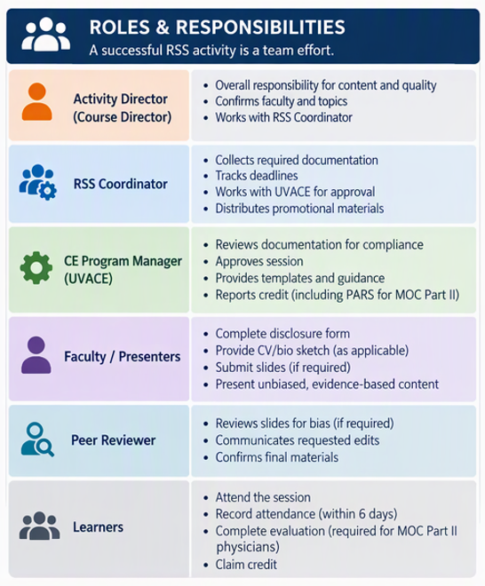

Submission Deadlines for all RSS activities:
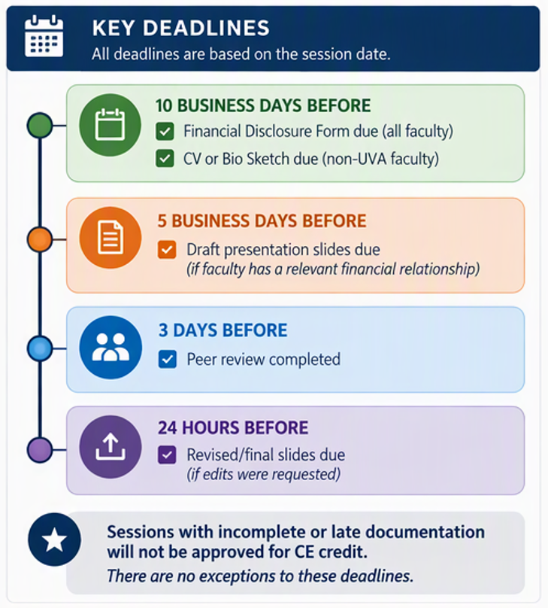
- Financial Disclosure Form - Due at least 10 business days prior to the session.
  - Faculty must have a financial disclosure form on file that was completed no more than 364 days prior to a session.
- CV or Bio Sketch - Due at least 10 business days prior to the session for non-UVA faculty.
- Presentation Slides - Due at least 5 business days prior to the session when the faculty has a conflict of interest on the financial disclosure form
When no relevant financial relationships are disclosed by faculty, presentation materials should be requested but are not required.
When relevant financial relationships are disclosed, draft slides must be shared so that the relationship(s) may be reviewed and mitigated prior to the session.
Draft materials requiring review must be submitted at least 5 business days before the session. This is to ensure adequate time for the peer reviewer to review the materials, as well as for the faculty to make any needed revisions to their materials prior to presenting.
Once draft slides are uploaded into CloudCME, UVACE will assign/notify the peer reviewer to complete the review. Peer reviewers have until 3 days prior to the session to complete the peer review.
If there are requested edits, the peer reviewer communicates those directly via CloudCME to the faculty, and revised slides need to be uploaded at least 24 hours prior to the session. The finalized materials must be uploaded to CloudCME for accreditation records as proof of no bias.

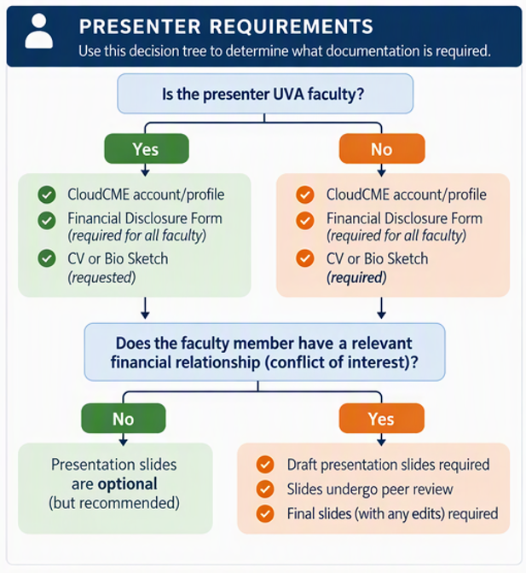
Presenter Requirements
- Complete CloudCME account/profile
- Financial Disclosure Form completed in CloudCME – required for all faculty
- CV or bio sketch to prove expert content knowledge base
  - Requested from all faculty
  - Required for non-UVA faculty
- Draft presentation slides
  - Requested from all faculty
  - Required when faculty have a conflict of interest for review/mitigation
- Final presentation slides for any peer-reviewed slides that require edits.

Additional Requirements
- Peer Review Completed (If COI disclosed)
- Promotional materials distributed to learners prior to the session.
**For sessions offering MOC Part II, see additional required documentation in Section II.

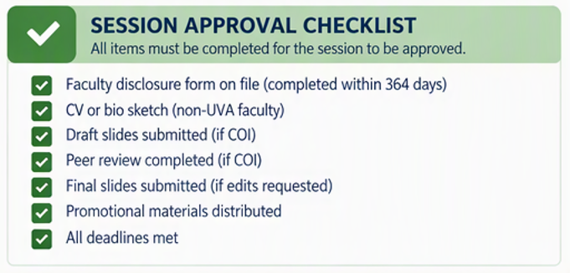
Session Approval
All required documentation must be received by the established deadlines.
Sessions with incomplete or late documentation will not be approved for CE credit. It is the responsibility of planners and coordinators to ensure items are submitted on time; they will not be reminded by UVACE as deadlines approach.
If a session is not approved:
- Learners may not claim CE credit.
- The session may not be advertised as accredited.
- The session/activity is de-activated in the system
There are no exceptions to these deadlines. UVACE understands that faculty have limited capacity, and it can be difficult for some to meet deadlines, especially since presenting is in addition to regular duties. However, to meet national accreditation requirements, these deadlines must be met.

Tips for Success!
To help organizers ensure that faculty successfully meet the expectations:
- Communicate early and often.
- Send faculty deadlines that are a few days earlier than the UVACE deadlines.
- Make it clear that if they do not submit on time, the session will not qualify for credit.
- If there is a chronically late faculty, work directly with their admin person for support.
- If it is close to the deadline, ask the Course Director to reach out directly to the faculty.
- Consider finding alternative faculty.
- If you know which faculty will be presenting in the upcoming year, consider asking them all at the same time to complete a financial disclosure. This allows planners to anticipate which draft slides will be needed. Faculty must have a financial disclosure form on file that was completed no more than 364 days prior to a session.
- If the activity frequently has faculty with financial conflicts, consider designating a second peer reviewer as a backup.

Promotion & Notification Materials
For accreditation purposes, learners must be notified of this information prior to a session via a promotional flyer:
- Title/topic, date, time & location
- Course Director, Planning Committee & Faculty
- Program Overview
- Targeted Audience
- Desired Outcomes
- Accreditation & Designation Statements
- Disclosure of Financial Relationships Statements
- Faculty & Planning Committee Financial Disclosures
- How to Receive Credit, including deadlines
**For sessions offering MOC Part II, see additional required documentation in Section II.
Flyers may be distributed once the faculty has completed their disclosure. If you also want to communicate accreditation information on slides immediately before the session starts, contact UVACE for the templates.
If the remaining deadlines are not met (eg. faculty has a conflict of interest and does not submit their draft slides at least 5 business days prior to the session), or the session is not approved for some other reason, notify the learners as soon as possible that the session will not offer credit. Ask UVACE for support.

Recording Attendance & Claiming Credit
For non-MOC RSS activities: learners have 6 days to record attendance via texting or entering a code on the website. Credit is claimed automatically upon recording attendance.
See Section II for MOC Part II sessions claiming credit process.

Session Evaluations
Evaluations for sessions not offering MOC Part II are encouraged and optional for all learners.
Evaluations for sessions offering MOC Part II are required for physicians. Evaluations are encouraged and optional for all other learner professions. See guidance in Section II.

Industry Involvement
Pre-approval by UVA CE is required prior to inviting an industry employer or owner to present.
Commercial support for RSS programs is limited to educational grants. Please contact your program manager for pre-approval. Exhibits and other industry marketing is prohibited.

Documentation and Record Retention
RSS activities must maintain sufficient documentation to demonstrate compliance with accreditation requirements, including:
- Disclosure forms
- CVs or bio sketches of non-UVA faculty
- Peer review records
- Peer reviewed final presentation materials
- Promotional materials
- Attendance records
- Learner evaluations
- Correspondence related to compliance
Records must be maintained in accordance with institutional retention policies and accreditation requirements.

Staffing & Training
All activities must have a designated Activity Director and RSS Coordinator.
If personnel change, please reach out to the CE office at uvace@uvahealth.org as soon as possible so we may update your series records and ensure disclosures have been completed and reviewed. Any delay may result in sessions not approved for credit.
New Directors and Coordinators will complete onboarding training within 30 days to maintain eligibility.
It is recommended that this policy document and the RSS Coordinator Guidebook are shared with the RSS Coordinator’s supervisor.
It is recommended that activities identify an alternate RSS Coordinator who understands the process and can provide continuity of support.
As part of the application and re-application process, all Course Directors and RSS Coordinators will review a brief refresher training course prior to application submission.

Quality Assurance
Periodic Audits: If an audit identifies an area of noncompliance, the department will be notified and provided with recommendations for improvement. A subsequent session will be re-audited to verify compliance. If the second audit continues to identify noncompliance, the department will be notified, and documentation of the noncompliance will be placed in the department's file. If a third audit identifies continued noncompliance, accreditation for the series may be withdrawn.

Noncompliance
Failure to meet RSS CE requirements may result in:
- Denial of session approval and de-activation of CE activity.
- Removal of CE credit eligibility.
- Corrective action for future sessions.

SECTION II. MOC Part II Requirements

Purpose
This section establishes additional requirements for activities offering Maintenance of Certification (MOC) Part II credit.

Scope
This policy applies to any accredited activity offering MOC Part II credit, including RSS activities, conferences, courses, and enduring materials.

Definitions
MOC Part II - Knowledge and self-assessment physician credit type requiring assessment and feedback. Relevant to only certain specialty boards.
Assessment Mechanism - The method used to evaluate physician learner engagement and learning.
Feedback - Information provided to learners regarding performance, key takeaways, best practices, or correct responses.
Participation Threshold - The minimum standard/effort a physician learner must meet to earn MOC Part II credit.
Attribution - The ability to identify and document individual physician learner participation and completion.
Eligibility - Activities wanting to offer MOC Part II credit for ACCME MOC Part II participating boards to physicians must complete a supplemental application and attestation as part of their every 2 year application cycle.

Eligibility
MOC Part II designation occurs at the session level.
Approval of an RSS activity requesting MOC Part II during the application phase does not automatically confer MOC Part II eligibility on all sessions within the series.
Only sessions meeting all applicable requirements may be designated and reported for MOC Part II credit.
MOC Part II credit is not offered during December.

Roles and Responsibilities
Course Director
- Determines which activities/sessions will pursue MOC Part II credit.
- Ensures educational design supports assessment and feedback requirements.
RSS Coordinator
- Coordinates MOC Part II implementation.
- Maintains documentation.
- Communicates learner requirements.
CE Program Manager
- Reviews compliance with MOC Part II requirements.
- Oversight of reporting and documentation.
- Activates MOC II points to claim for eligible sessions
- Configures evaluation for activities with MOC Part II
Faculty Presenter
- Participates in approved assessment and feedback processes.

Assessment Requirements
All MOC Part II activities must include an assessment mechanism that evaluates individual physician learner participation and learning.
RSS:
- All RSS activities offering MOC Part II are required to include a standardized evaluation (see Appendix E), including a written reflection, through CloudCME.
- Physicians must complete the evaluation and written reflection to claim credit. Credit will not be awarded to physicians without a completed evaluation. Physicians must complete the evaluation to receive CME credit and/or MOC credit. Evaluations are encouraged and optional for all other learner professions.

Feedback Requirements
All physician learners seeking MOC Part II credit must receive feedback before credit is awarded.
- Grand Rounds, Case-based discussion, Tumor Board, Journal Club, and M&M: Course directors must attest that learners receive feedback during sessions as part of learner engagement. A Q&A at the end is sufficient.

Attribution Requirements
Assessment data must be attributable to individual learners, which is often accomplished via the evaluation form.
Anonymous participation methods do not satisfy MOC Part II requirements.

Participation Thresholds
Each activity must establish a participation threshold appropriate to the assessment method used. This threshold is indicated on the supplemental MOC Part II application.
Examples include:
- Completion of a meaningful reflective statement (as part of the evaluation).
- Completion of a quiz with a minimum passing score.
- Participation in a documented educational exercise.
- Completion of audience response questions.
Participation thresholds must be documented and communicated to learners before the activity.

Recording Attendance & Claiming Credit
For MOC Part II RSS sessions:
- Physicians have 6 days to record attendance via texting or entering a code on the website.
- In addition, physicians have 6 days to claim continuing education credit and/or MOC Part II credit by completing the required evaluation. Credit is not awarded until the evaluation is completed.
  - This ensures that MOC Part II requirements for physician learners are completed prior to awarding credit.
- Other learners have 6 days to record attendance via texting or entering a code on the website. Credit is claimed automatically upon recording attendance.
UVACE will report eligible completions through ACCME PARS monthly. MOC Part II is not available during December for end of year reporting purposes. Learners can still claim CE during December.

Documentation Requirements
For each MOC Part II activity, documentation must include:
- Approved assessment method (typically as part of activity application).
- Participation threshold (typically as part of activity application).
- Evidence of learner participation.
- Evidence that threshold requirements were met.
- Feedback attestation or documentation.
- Learner roster (housed in CloudCME).
- PARS submission confirmation by UVACE.
**For RSS, please note that this is in addition to the required documentation outlined in Section I.

Noncompliance
If RSS CE requirements are not met:
- The session is not eligible for CE credit or MOC Part II credit.
If MOC Part II requirements are not met:
- The session may remain eligible for CE credit if RSS CE requirements were met.
- MOC Part II credit may not be awarded or reported.

SECTION III. RSS Offering MOC Part II Procedures

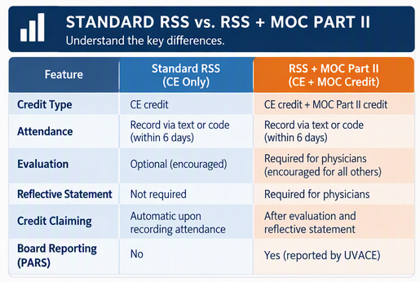
Planning and Application
The planning committee identifies whether MOC Part II credit will be requested.
The planning committee:
- Completes the additional documentation, as an appendix to the RSS activity application, including a supplemental MOC Part II application and attestation.
- Course Director confirms that funding is available for the additional $750 annual fee.
- The CE Program Manager reviews the proposal and obtains additional review when necessary.

Pathway
See RSS Coordinator Guidance document for specifics on how to complete these steps.
All RSS complete these steps for MOC Part II:
- RSS Coordinator ensures information from faculty is submitted by deadlines
- RSS Coordinator sends promotional flyer to potential learners
- Learner attends the session.
- As attested to during the application phase, feedback is incorporated as part of the session.
- All learners record attendance within 6 days and non-physician learners are automatically awarded credit.
- In addition, physicians have 6 days to claim continuing education credit and/or MOC Part II credit by completing the required evaluation. Credit is not awarded until the evaluation is completed.
- Eligible completions are reported through PARS.

Pre-Session Communications:
in addition to requirements in Section I for RSS.
Faculty must be notified of:
- During the session they are to:
  - Remind learners of participation requirements.
  - Encourage completion of evaluations and assessments (UVACE recommends suggesting allocating 5 minutes at the end of a session).
  - Provide educational feedback in the moment when appropriate.
Learners must receive:
- Requirements to earn MOC Part II credit.
- Participation threshold.
- Information regarding how feedback will be provided.

Post-Session Activities
Following the session:
- Learners should receive instructions for claiming credit, if they haven’t already.
- Evaluation responses
  - While the faculty person is not expected to review the reflection assessment as part of the evaluation (course directors must attest that reflection statements are sufficient to meet the participation threshold requirements), it is recommended that the activity share the finished evaluation report with them to provide presentation feedback and potential promotional documentation.

Learner Claim Window
All learners must record attendance within 6 days of the session.
In addition:
- In addition, physicians have 6 days to claim continuing education credit and/or MOC Part II credit by completing the required evaluation. Credit is not awarded until the evaluation is completed.
  - This ensures that MOC Part II requirements for physician learners are completed prior to awarding credit.
- Other learners: credit is claimed automatically upon recording attendance. Encourage learners to complete the optional evaluation.
UVACE will report eligible completions through ACCME PARS monthly. MOC Part II is not available during December for end of year reporting purposes. Learners can still claim CE during December.

Physician MOC Part II Credit
- To receive MOC Part II credit, physicians must ensure their CloudCME account contains the necessary information for reporting. If this information is not in CloudCME, the credit cannot be reported to the board. Required fields:
  - Degree: MD
  - Profession: Physician
  - Birth Month
  - Birthday
  - NPI number
  - “Will you be claiming MOC points” must be checked yes
  - Specialty Board
  - Diplomate ID (if they do not know it, there are links to the board lookup pages)
  - The last checkbox “I provide permission…certifying boards” must be checked

Reflective Statements
The course director attests that those claiming credit have met the minimum threshold in the form of a meaningful reflective statement as part of the evaluation.
Reflective statements that do not demonstrate meaningful engagement may require follow-up or remediation and may result in no MOC Part II credit being reported.

Reporting
UVACE will report eligible completions through ACCME PARS monthly. MOC Part II is not available during December for end of year reporting purposes. Learners can still claim CE during December.

Quality Assurance
UVACE may conduct periodic audits to verify:
- Assessment documentation.
- Participation thresholds.
- Learner attribution.
- Feedback attestation or documentation.
- Timely reporting.
- Compliance with accreditation standards.

APPENDIX A. Sample Faculty Communications

A1. RSS Session – No MOC Part II
Thank you for agreeing to present at the upcoming [Series Name] conference.

Please complete the following requirements within the stated timeframes. Failure to do so may result in the session not being approved for continuing education credit.

- Complete your Financial Disclosure Form in CloudCME no later than 10 business days prior to the session.
- Submit your CV or bio sketch to CloudCME no later than 10 business days prior to the session (requested for all faculty and required for non-UVA faculty).
- Please upload a copy of your slides to CloudCME. See attached instructions.
  - If you have financial relationships, you are required to submit draft presentation slides no later than 5 business days prior to the session for review and mitigation.
    - Presentations slides may be a rough draft with minor revisions made later but should not be major revisions that alter the content.
- Ensure educational content is evidence-based, balanced, and free from commercial bias.

Thank you for helping us maintain accreditation compliance.

A2. Material Submission Request due to Financial Conflict of Interest

Thank you for completing the financial disclosure form. To mitigate potential inadvertent bias due to your financial conflicts of interest, we need to review your materials.

Please upload your draft slides/materials in CloudCME by XXX date. (minimum 5 days prior to session).

Failure to do so will mean that we cannot offer credit for this session.

Materials may be a rough draft with minor revisions made later but should not be major revisions that alter the content.

To upload go to CloudCME > Faculty (blue banner, orange tab) > Upcoming Presentations

Materials may be uploaded as a .ppt or .pdf.

If you have difficulties uploading, feel free to send them to me directly and I can do so for you.

If the peer reviewer has required edits, you will be notified via an email from CloudCME by 3 days prior to the session. You will have until 24 hours prior to the session to upload the final version of your slides.

If the peer reviewer does not have required edits, then you do not need to submit final slides.

This is a requirement of national accreditation standards so that we may offer credit. Thank you for your understanding and for your efforts to make this a high quality and valid education session.

A3. RSS Session with MOC Part II

Thank you for agreeing to present at the upcoming [Series Name] conference.

This session aims to offer MOC Part II credit and has additional accreditation requirements.

Please complete the following requirements within the stated timeframes. Failure to do so may result in learners not receiving continuing education or MOC Part II credit.

Summary:
- By XXX date complete disclosure form and upload CV.
- By XXX date upload draft slides. This is required if you have financial conflicts.

Details:

- Complete your Financial Disclosure Form in CloudCME no later than 10 business days prior to the session.
- Upload your CV or bio sketch to CloudCME no later than 10 business days prior to the session (requested for all faculty and required for non-UVA faculty).
- Please upload a copy of your slides to CloudCME. See attached instructions.
  - If you have financial relationships, you are required to submit draft presentation slides no later than 5 business days prior to the session for review and mitigation.
    - Presentations slides may be a rough draft with minor revisions made later but should not be major revisions that alter the content.
- During the session:
  - Please remind physician learners that they need to complete an evaluation to claim credit.
  - Incorporate opportunities for learner engagement and feedback, such as discussion, case-based application, evidence review, or facilitated reflection and provide feedback in the moment when appropriate. This can be accomplished via Q&A.
  - We encourage presenters to reserve approximately 5 minutes at the end of the conference for physician learners to complete evaluations and reflective statements required for MOC Part II credit.

APPENDIX B. Sample Learner Communications

B1. Pre-Session – RSS Without MOC Part II
(no post-session email needed)
Please see attached flyer for session information.

To claim credit, you must record attendance by XXX date.
Use this Activity ID code:
Choose One:
- The CloudCME app and select claim credit, then enter the above code; OR
- Text the code to 1-855-474-8287. In order for this to work, ensure that your CloudCME profile has your phone number; OR
- Log your attendance through the website: UVA.cloud-cme.com > MyCE > Claim Credit

See attached guidance document to help with how to claim credit in CloudCME.

We encourage all learners to complete optional evaluation form, located in CloudCME under ‘My Evaluation’ once you have claimed credit.

{UVACE recommends attaching the “how to claim credit” guidance document to these emails}

B2. Pre-Session – RSS With MOC Part II
(no post-session email needed)
This session offers continuing education credit and MOC Part II credit. See attached flyer for session information.

To claim credit you must do the following by XXX date.

Physicians: to earn AMA PRA Category 1TM credits and MOC Part II credit you must:

* Attend the session.
* Ensure your CloudCME profile has the necessary info (see below), or else credit cannot be reported.
* Record attendance through CloudCME within 6 days of the session (see below for instructions).
* Complete the activity evaluation within 6 days of the session. You should be automatically taken to the evaluation upon recording attendance, and we encourage you to do this soon after the activity.
* Submit a meaningful reflective statement as part of the activity evaluation.

Your reflective statement should describe a specific:

* Insight or takeaway,
* Intended practice change,
* Application of learning, or
* Professional improvement opportunity.
Participation threshold: Reflective statements are reviewed. Statements that do not demonstrate meaningful engagement, such as “I attended” or “n/a” do not qualify for MOC Part II credit and credit may not be reported.
All learners: use this Activity ID code to claim credit: XXXXX
To record attendance, choose:
- The CloudCME app and select claim credit, then enter the above code; OR
- Text the code to 1-855-474-8287. In order for this to work, ensure that your CloudCME profile has your phone number; OR
- Log your attendance through the website: UVA.cloud-cme.com > MyCE > Claim Credit

Evaluations are required for physicians to claim credit.

All other learners are automatically awarded credit once they record attendance. Non-physician learners are encouraged to complete an evaluation form (but it is not required to claim credit), located in CloudCME under ‘My Evaluation’ once you have claimed credit.

Feedback occurs during sessions as part of physician learner engagement.
Physician CloudCME profile: if this information is not in CloudCME, credit cannot be reported to the board. UVA.cloud-cme.com > MyCE > Profile
Required fields:
  - Degree: MD
  - Profession: Physician
  - Birth Month
  - Birthday
  - NPI number – NPI Lookup
  - “Will you be claiming MOC points” must be checked yes
  - Specialty Board
  - Diplomate ID (use applicable board link listed below the field to look it up)
  - The last checkbox “I provide permission…certifying boards” must be checked

Eligible completions will be reported through ACCME PARS and participating certifying boards after all requirements are verified. MOC Part II credit is not available during December for end of year reporting purposes. Learners can still claim CE credit during December.

APPENDIX C. Compliance Checklists

RSS with No MOC
□ Disclosures completed (10 business days)

□ CV/Bio received (required for non-UVA, requested for all) (10 business days)

□ Slides uploaded (required if have financial conflict, requested for all) (5 business days)

□ Financial conflict materials review completed if applicable (at least 3 days prior to session)

□ Final slides uploaded if applicable (at least 24 hours prior to session)

□ Flyer sent (prior to session)

□ Session approved for CE

□ Learners claim credit, evaluation optional for all

RSS with MOC Part II
□ Disclosures completed (10 business days)

□ CV/Bio received (required for non-UVA, requested for all) (10 business days)

□ Slides uploaded (required if have financial conflict, requested for all) (5 days)

□ Financial conflict materials review completed if applicable (at least 3 days prior to session)

□ Final slides uploaded if applicable (at least 24 hours prior to session)

□ Flyer sent prior to session, including learner requirements (prior to session)

□ Participation threshold documented:

* Attendance (via CloudCME)
* Evaluation (via CloudCME)
* Meaningful reflective statement (via evaluation)

□ Feedback as part of session day

□ Learners claim credit, evaluation required for physicians, optional for others

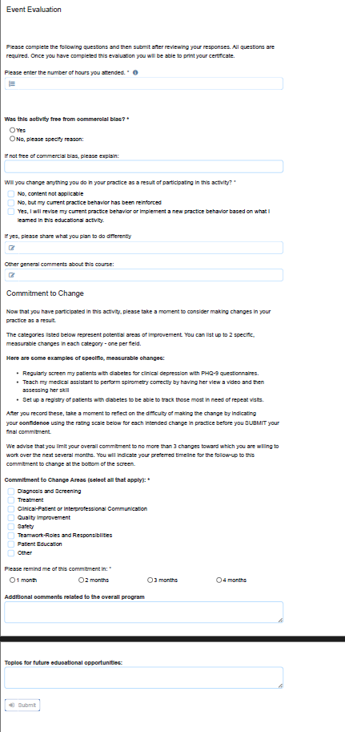
APPENDIX D: Standardized Evaluation Form
with Reflective Statement for MOC Part II

APPENDIX E: Additional Resources

Find these resources on CloudCME:
https://uva.cloud-cme.com/content/planning-resources

RSS Planning Resources
- RSS Accreditation Guide (this document)
- RSS Coordinator Training Manual for CloudCME
- RSS Training Modules for Course Directors, RSS Coordinators, and Planners
- MOC Part II Application & Attestation

CloudCME How-To Guides
- Financial Disclosure: How-to Guide for CloudCME
- Faculty: How-to Guide for CloudCME (submit disclosure, upload CV, presentation)
- Learner: How to Claim CE
- Peer Reviewer: How-to Guide for CloudCME
- Physician Learner: How to Claim MOC II Points

